InComm

TIBCO API Exchange Manager

**User Guide**

Version <1.0>

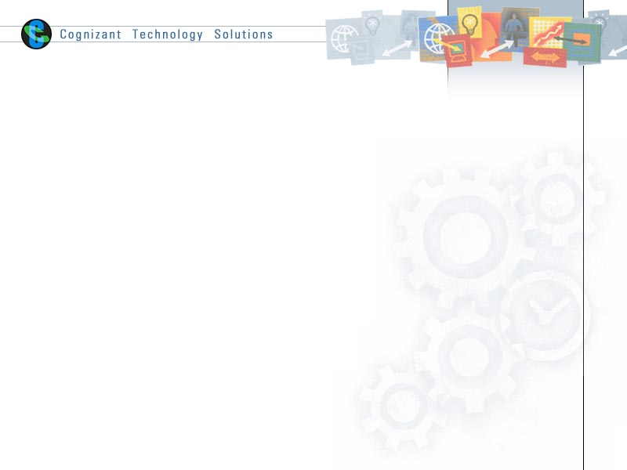

|  |  |  |  |
| --- | --- | --- | --- |
|  | **Prepared By / Last Updated By** | **Reviewed By** | **Approved By** |
| **Name** | Vinay Honnavara B |  |  |
| **Role** |  |  |  |
| **Signature** |  |  |  |
| **Date** | 22 May 2015 |  |  |

Table of Contents

1.0 Document Overview 3

1.1 Document Purpose 3

1.2 References 3

1.3 Definitions, Acronyms and Abbreviations 3

2.0 TIBCO APIX Joomla & Manager Setup 3

2.1 Joomla 3

2.2 API Manager Portal 4

2.3 XXXXX 10

3.0 Appendix A – Change Log 10

# Document Overview

## Document Purpose

This document is intended to provide guideline on setting up TIBCO API Manager. As a pre-requisite,

It is required to have Joomla & TIBCO API Manager installed and configured successfully as per the product installation document.

It is required to have API Gateway project to be configured in TIBCO Gateway ConfigUI. (Please refer XXXXXXXX document).

## References

Use this section to fill-in reference documents used

|  |  |
| --- | --- |
| ***Document#*** | ***Document Title*** |
|  |  |
|  |  |

## Definitions, Acronyms and Abbreviations

Use this section to fill-in definitions of acronyms & abbreviations used in this document

|  |  |
| --- | --- |
| ***Term, Acronym*** | ***Definition*** |
|  |  |
|  |  |

# TIBCO APIX Joomla & Manager Setup

## Joomla

1. Start WAMP server.

OR

Start Apache, MySQL & PHP.

1. Run Joomla Portal at :

http://<hostname>:<joomlaport>/administrator/

(<http://localhost:9500> /administrator/).

1. Login to the portal with appropriate creds (admin,admin)
2. Select Global Configuration > API Manager and Set ConfigUI URL as

http://<gatewayhostname>:<gatewayport>

(“<http://localhost:9222>)

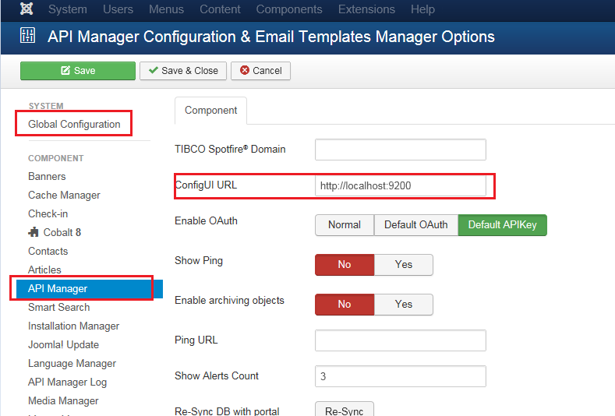

## API Manager Portal

1. Run API Manger Portal at

http://<hostname>:<port>/

(<http://localhost:9500>)

1. Navigate to asg install directory ( /opt/tibco/asg/2.1/bin). Run PortalProject with the following command

./asg-portal-engine -a PortalProject

1. Login to the portal with appropriate creds (admin,admin)
2. Create a new Environment
   1. Click on Environment tab and click Create Environment.
   2. Provide appropriate values as shown below.
      1. Environment name : Appropriate name for the environment (Dev, QA, Prod etc.,.
      2. Description : A brief description for this environment
      3. Type : Select appropriate type from the drop-down
      4. Basepath : http://<gatwayhostname> :<gateway port>

for eg: (<http://localhost:9222>)

* + 1. Managed by Gateway : “Yes”
  1. Save the settings

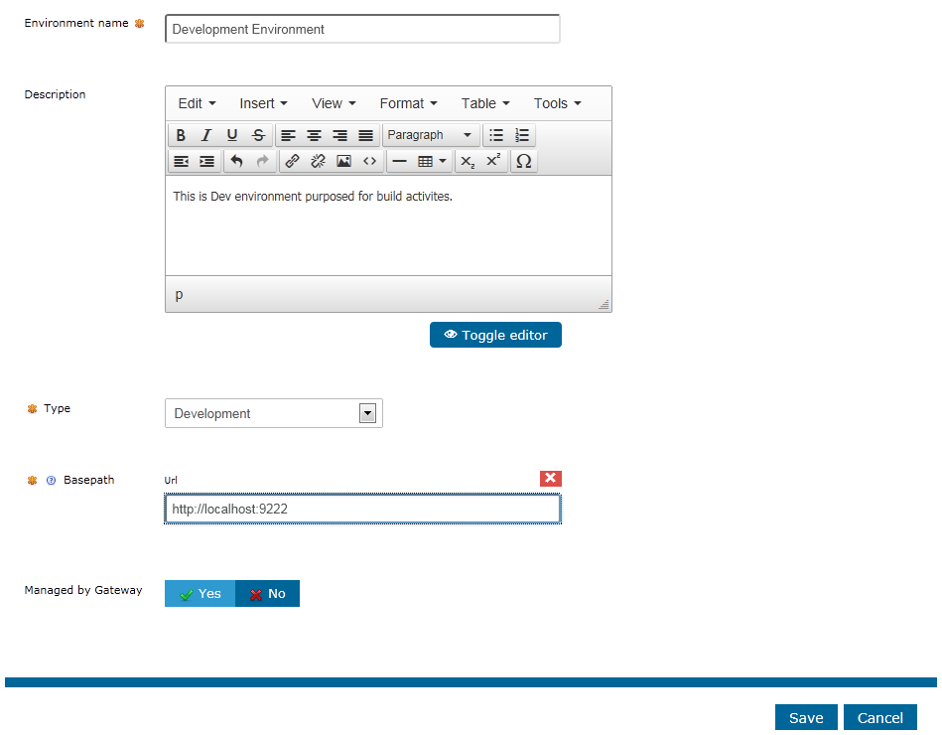

1. Click on “Add Gateway” and add the details as shown

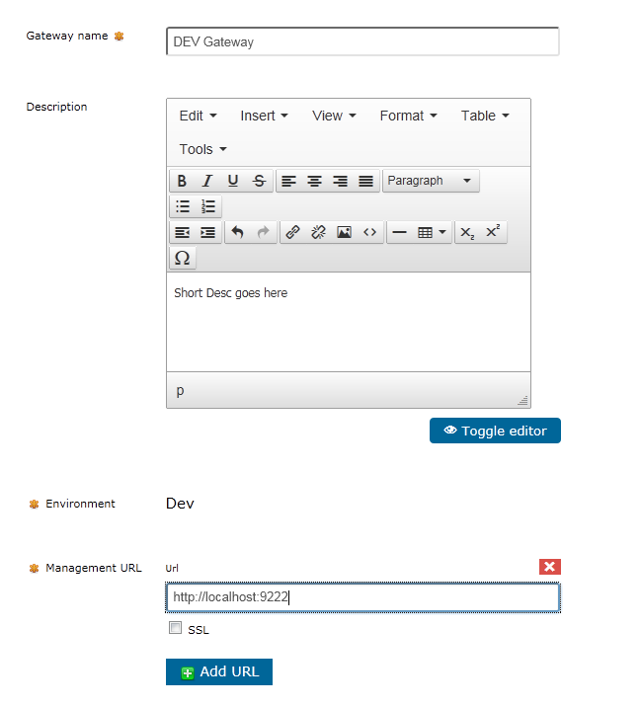

1. Create an API.
   1. Click on APIs on main menu
   2. Click Create New API and provide the following details
      1. API Name : Appropriate name for the API
      2. Desc : Short description about the service
      3. API Type : Select appropriate type from the dropdown (REST / SOAP)
      4. Create Proxy for API : Select No

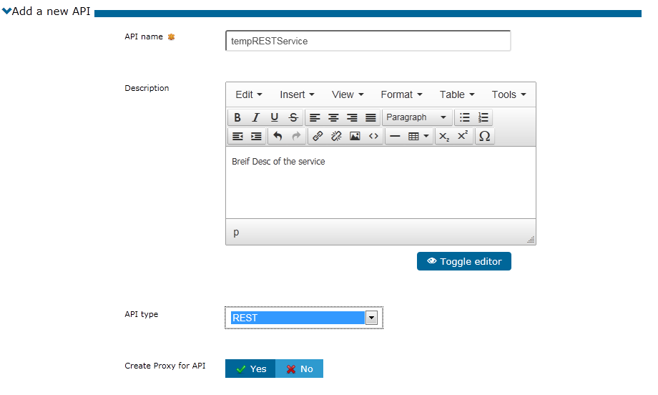

* 1. Upload the API spec and add environments
     1. Upload REST OR WSDL API spec (Add appropriate json OR wsdl file provided by the API team).
     2. Enivronment : Set Environment to previously created Environment by clicking the Choose button.
  2. Enter or upload documentation
     1. Attached documentation files : Optional step
     2. Inline documentation text : Optional step

1. Add Operation to API.
   1. Click on the API previously created.
   2. Click on Add Operation
   3. Make entries as shown
      1. Operation name : Suitable name for the operation
      2. Desc : Short Desc for the operation
      3. URI Path : Actual uri of the service (for eg: /foo/customer/list/getbyid)
      4. Rest Method : select the method of the service

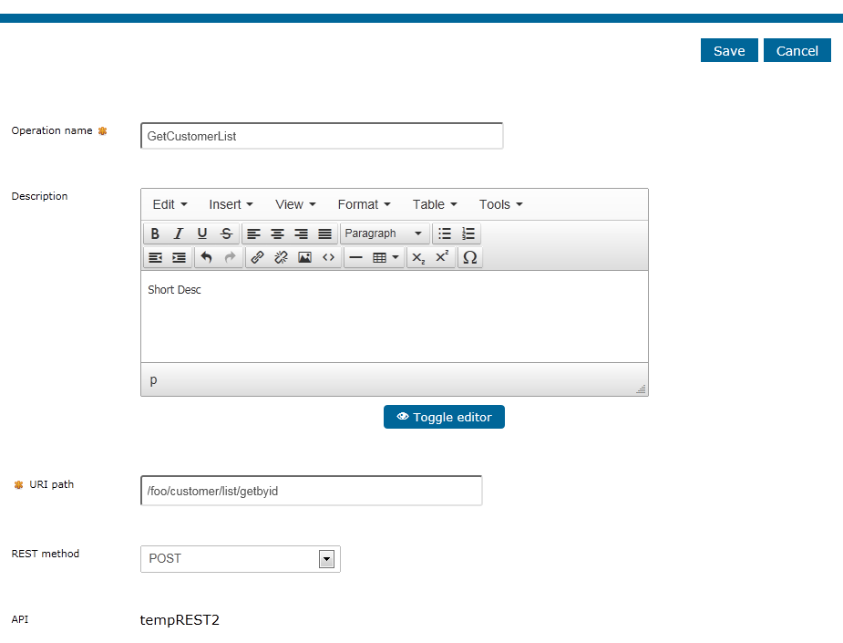

1. Create Product
   1. Click on Products in the main menu
   2. Click Create New Product
      1. Name of Product : Appropriate Name for the Product
      2. Desc : Short Desc about the product
      3. Product category : Select Reference Data

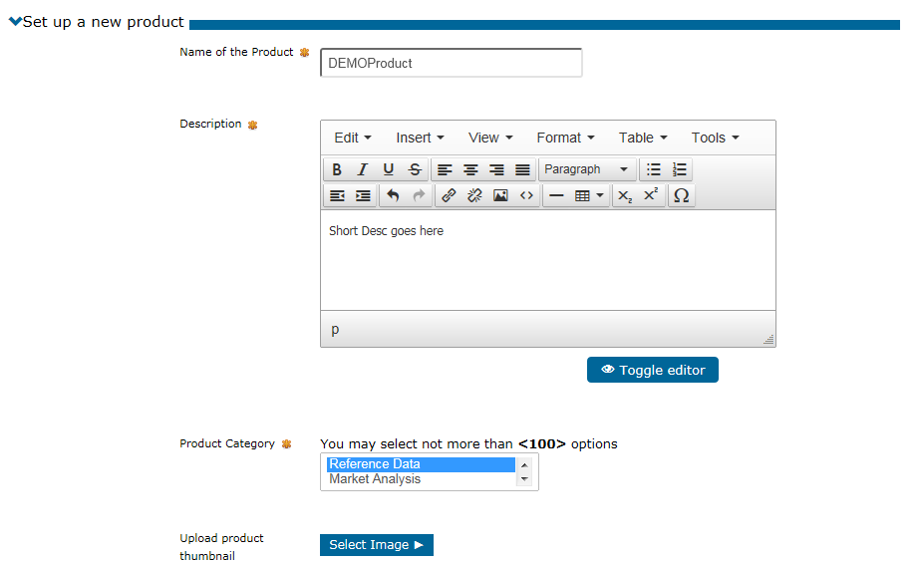

* 1. Associate your product with APIs
     1. APIs : Choose the API created in previous step
  2. Enter or upload documentation : optional setup

1. Add a Plan to the Product
   1. Click on the Product created in the previous step
   2. Click Products> Product > Add plan
      1. Plan Name : Name for plan
      2. Level : Select from the dropdown
      3. Price : Set the price
      4. Auto Subscribed : Check this, if the user can subscribe to the plan without approval from admin
      5. RateLimit : Set the appropriate level
      6. Quota Limit : set the appropriate level

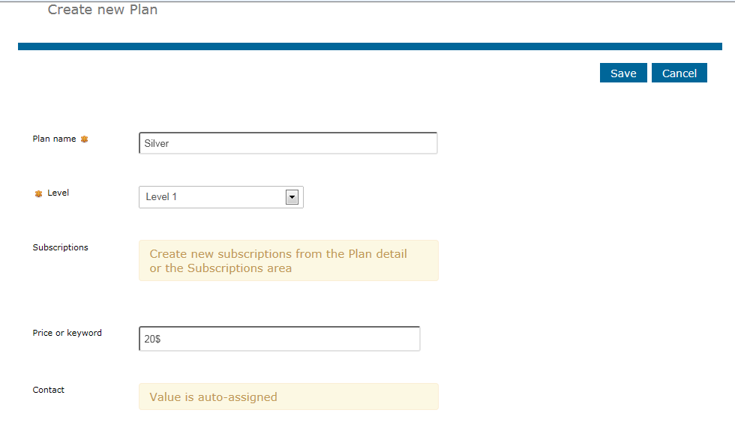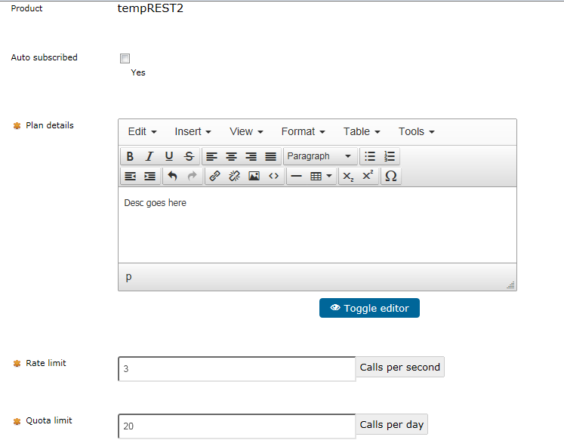

1. Create Application
   1. Applications>Register Application
      1. Provide Appropriate Application name and save
      2. Generate APIKEY for the application.

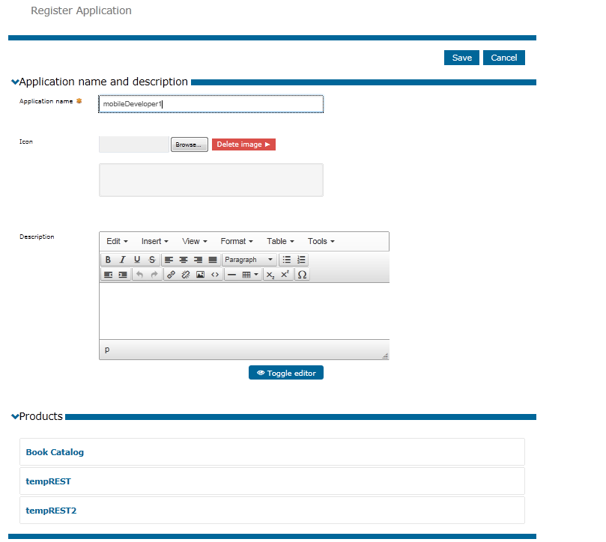



1. Request Subscription
   1. Log in to portal as developer (optional, can continue as admin)
   2. Products > Product > Request Subscription :
   3. Select the application created in previous step and confirm request

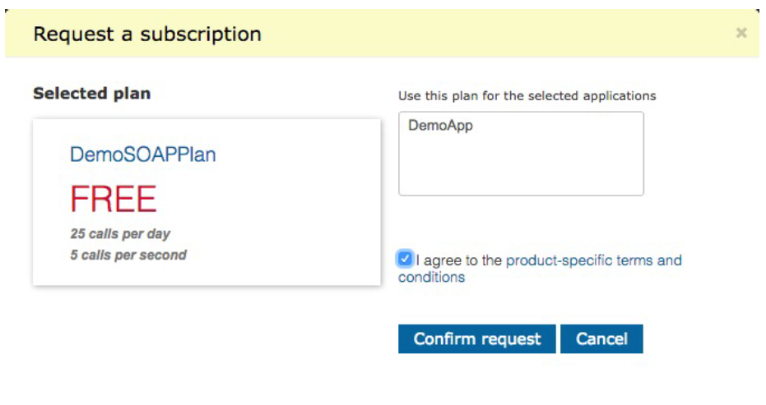

This should conclude creation of APIs , Bundling them into products & user subscription to the product.

## XXXXX

# Appendix A – Change Log

|  |  |  |  |  |
| --- | --- | --- | --- | --- |
| ***Version Number*** | ***Changes Made*** | | | |
| Vx.y | Initial baseline created on xx-Feb-2014 | | | |
| Vx.y |  | | | |
| **Section No.** | **Changed By** | **Effective Date** | **Changes Effected** |
|  |  |  |  |
| Vx.y |  | | | |
| **Section No.** | **Changed By** | **Effective Date** | **Changes Effected** |
|  |  |  |  |
| Vx.y |  | | | |
| **Section No.** | **Changed By** | **Effective Date** | **Changes Effected** |
|  |  |  |  |